**Student’s name: Nguyen Van Ty (M5231130)**

**Report of Machine Learning Course #4**

**TRY TO RE-FORMULATE THE PROCESS FOR DETERMINING THE DISTANCE OF A SUBJECT BASED ON N OBSERVATIONS, WITH THE BINOMIAL DISTRIBUTION**

A binary sensor always outputs the Boolean value 0 or 1 (0: no detected person, 1: detected person) and if we consider number of ones in N observed data, it will follow a binomial distribution.

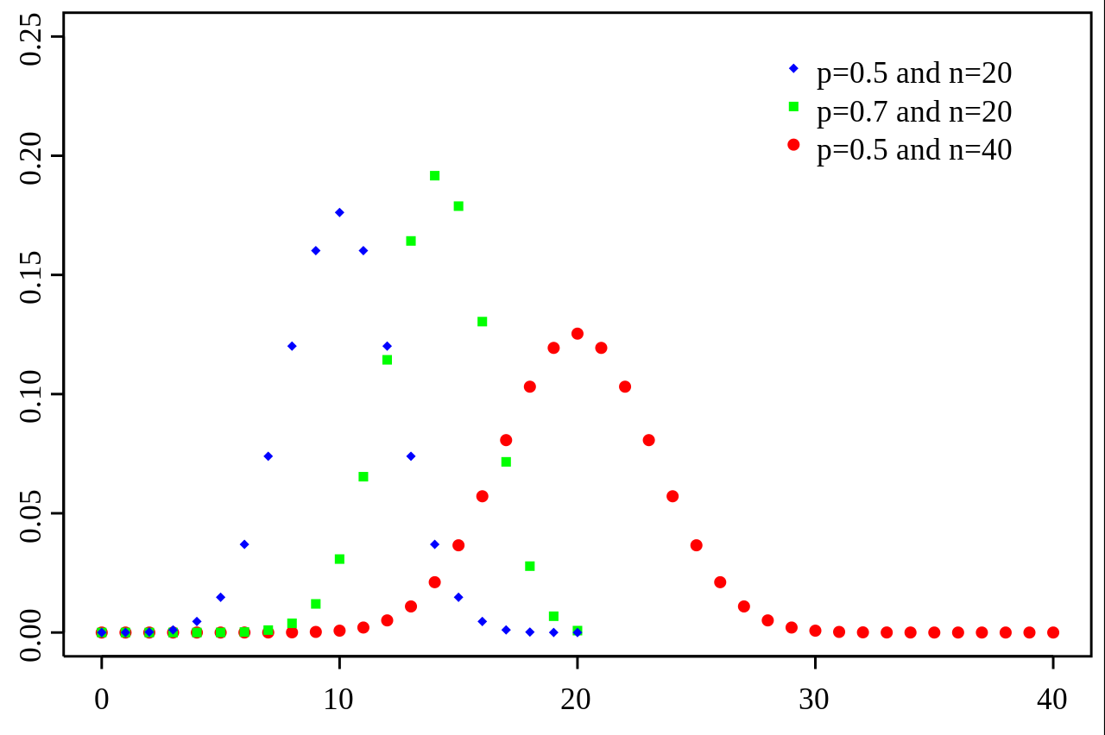

*An example of probability mass function for the binomial distribution.*

The Binomial Distribution function is:

$$p=\frac{n!}{k!\left(n-k\right)!}p^{k}{(1-p)}^{n-k}$$

Apply to the problem determining the distance of a subject based on N observation, we have:

$$p=\frac{N!}{k!\left(N-k\right)!}×{0.5}^{k}×{0.5}^{N-k}$$

With:

*N:* Observations data

*k* = 0, 1, 2, … *N*

*p* and *(1– p)* = 0.5: Probability of two Boolean value 0 and 1.